Image Optimization

Definition
# Source: AI Source: Provided by: [Data Path: Persons Table -> ID Column: 1, Name_En Column: Motasem Essam] -> From: [Chatgpt (GPT‑5 Mini)] on [2/12/2026]
Image Optimization is a web design technique that involves reducing the file size of images without losing much quality, so that a website loads faster and performs better.

Simple Definition
# Source: AI Source: Provided by: [Data Path: Persons Table -> ID Column: 1, Name_En Column: Motasem Essam] -> From: [Chatgpt (GPT‑5 Mini)] on [2/12/2026]
Image Optimization = making images smaller in size but still clear and good-looking.

How Image Optimization Works
# Source: AI Source: Provided by: [Data Path: Persons Table -> ID Column: 1, Name_En Column: Motasem Essam] -> From: [Chatgpt (GPT‑5 Mini)] on [2/12/2026]
• Compressing images to reduce file size
• Choosing the right file format (JPEG, PNG, WebP, etc.)
• Resizing images to the correct dimensions
• Removing unnecessary image data (metadata)
• Using modern formats for better compression

Purpose of Image Optimization
# Source: AI Source: Provided by: [Data Path: Persons Table -> ID Column: 1, Name_En Column: Motasem Essam] -> From: [Chatgpt (GPT‑5 Mini)] on [2/12/2026]
• Improve website loading speed
• Reduce bandwidth usage
• Enhance user experience
• Improve SEO (search engine ranking)
• Make websites more efficient

Advantages
# Source: AI Source: Provided by: [Data Path: Persons Table -> ID Column: 1, Name_En Column: Motasem Essam] -> From: [Chatgpt (GPT‑5 Mini)] on [2/12/2026]
• Faster page loading
• Better performance on mobile devices
• Saves storage and bandwidth
• Improves user satisfaction
• Helps websites rank higher in search engines

Disadvantages
# Source: AI Source: Provided by: [Data Path: Persons Table -> ID Column: 1, Name_En Column: Motasem Essam] -> From: [Chatgpt (GPT‑5 Mini)] on [2/12/2026]
• Over-compression can reduce image quality and make visuals look blurry
• Requires balance between file size and quality, which can be difficult
• Using too many image formats may complicate workflow
• Needs tools or plugins, which can add extra steps
• Incorrect resizing may distort images
• Some optimization methods require technical knowledge
• Re-optimizing images can take time when updating content

Examples
# Source: AI Source: Provided by: [Data Path: Persons Table -> ID Column: 1, Name_En Column: Motasem Essam] -> From: [Chatgpt (GPT‑5 Mini)] on [2/12/2026]
• Compressing a large image before uploading it to a website
• Using smaller images for thumbnails
• Using modern formats like WebP for faster loading
• Resizing a 4000px image to 800px for web use

Difference Between Image Optimization and Other Techniques
# Source: AI Source: Provided by: [Data Path: Persons Table -> ID Column: 1, Name_En Column: Motasem Essam] -> From: [Chatgpt (GPT‑5 Mini)] on [2/12/2026]
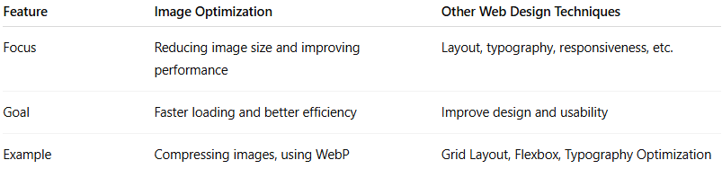
Feature | Image Optimization | Other Web Design Techniques
Focus | Reducing image size and improving performance | Layout, typography, responsiveness, etc.
Goal | Faster loading and better efficiency | Improve design and usability
Example | Compressing images, using WebP | Grid Layout, Flexbox, Typography Optimization

